Welcome! If you are new to Discourse, here is a how-to guide to help you get started and get the most out of this Discourse forum.

Before diving into the details, please note that from now on we’ll only be using Discourse for learner support. For any questions or feedback about our courses, please post them in Discourse instead of the Coursera Forum or Slack. The Discourse invitation link only works once, but don’t worry once you have created an account on our Discourse, you’ll also have access to other future courses that you enroll. To allow quick and easy access to Discourse, a friendly reminder for you to bookmark our Discourse page in your browser. <https://discourse.deeplearning.ai/>

**-Table of Contents-**

You can click the link below to jump to a section. Or simply scroll down and read through each of the sections.

1. Overview of Discourse
2. Guidelines
3. Tips
4. User trust levels
5. Getting setup

### Overview of Discourse

**Discourse > Categories> Sub-categories > Topics > Reply**

1. Discourse is broken into categories. It’s the primary means for organizing topics. Here are the categories open to all learners:
   * [Deep Learning Specialization Refresh](https://discourse.deeplearning.ai/c/deep-learning-specialization/6)
   * [General Coursera Tips](https://discourse.deeplearning.ai/c/general-coursera-tips/22)
   * [General Site Feedback](https://discourse.deeplearning.ai/c/site-feedback/2)
   * [Uncategorized](https://discourse.deeplearning.ai/c/uncategorized/1)
   * [Job Opportunities](https://discourse.deeplearning.ai/c/deep-learning-specialization/job-opportunities/21)
2. Within a category are subcategories. For example, within [Deep Learning Specialization Refresh](https://discourse.deeplearning.ai/c/deep-learning-specialization/6), there are:

* [DLS Announcements](https://discourse.deeplearning.ai/c/deep-learning-specialization/announcements/19)
* [DLS Introductions](https://discourse.deeplearning.ai/c/deep-learning-specialization/introductions/18)
* [DLS Feedback](https://discourse.deeplearning.ai/c/deep-learning-specialization/feedback/20)
* [DLS Course 1](https://discourse.deeplearning.ai/c/deep-learning-specialization/dls-course-1/12)
* [DLS Course 2](https://discourse.deeplearning.ai/c/deep-learning-specialization/dls-course-2/13)
* [DLS Course 3](https://discourse.deeplearning.ai/c/deep-learning-specialization/dls-course-3/14)
* [DLS Course 4](https://discourse.deeplearning.ai/c/deep-learning-specialization/course-4/15)
* [DLS Course 5](https://discourse.deeplearning.ai/c/deep-learning-specialization/dls-course-5/16)

1. Within subcategories there are topics. They are a collection of messages grouped together. You can post questions, course feedback or thoughts to initiate a discussion by creating a topic, or you can reply to a topic to take part in a conversation. This is also where the major support from our mentors will take place.

At the end of the original post you will also see lists of related topics that link to the one you are reading.

1. To go to the homepage, clicking the logo at the top left will take you back no matter where you are.

Tags

### Guidelines

* + Before creating a new topic, **search for your question/topic on the top right corner** as someone might have already created one with your question or comment. When you are creating a new topic, Discourse will automatically send you a notice if your topic is similar to a previous post.

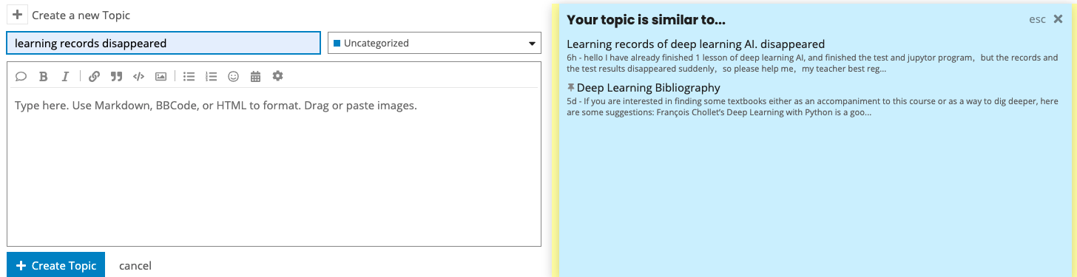

* + When creating a new topic, make sure to select the right category and subcategory so that the correct mentors are able to quickly respond to your question.
  + 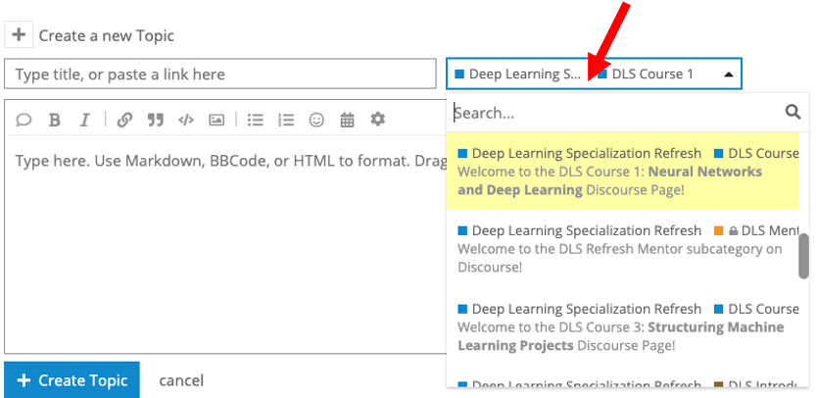
  + Write descriptive titles in your posts.
  + Give enough context about your question. Here is an example of a well-phrased question for your reference. 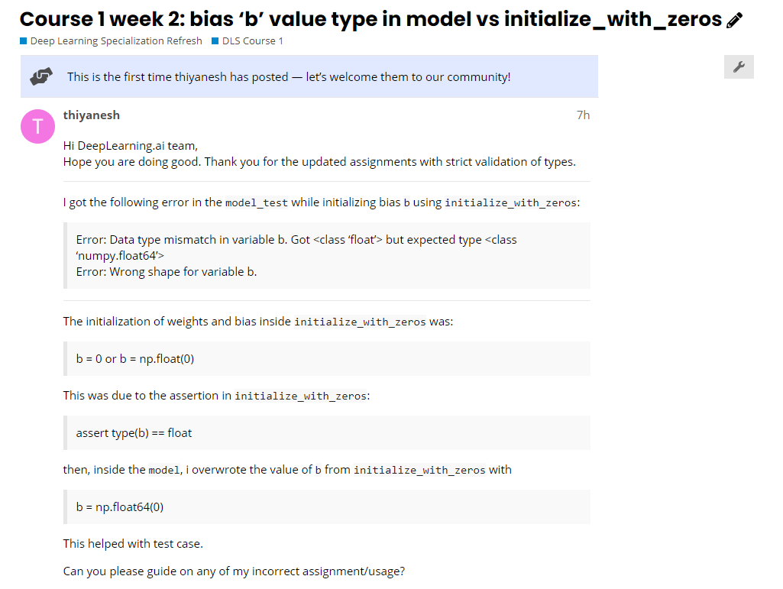
  + Avoid using capital letters except when starting new sentences or well-known acronyms (ex: GANs).
  + Do not share answers to quizzes, notebooks, or share code.
  + Be kind to other members of the community.
  + Report inappropriate behavior to mentors or DeepLearning.AI staff. More information can be found in [Coursera’s code of conduct](https://coursera.community/site/terms)

### Tips

* + **Bookmark**: bookmark a topic that you found helpful so you can easily find them. 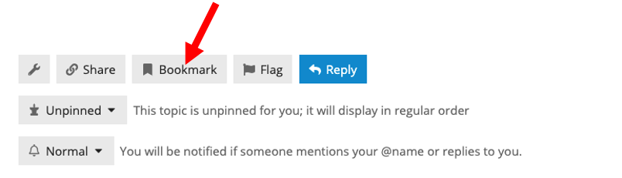You can review your list of bookmarks by clicking your profile image on the top right and choosing bookmarks.

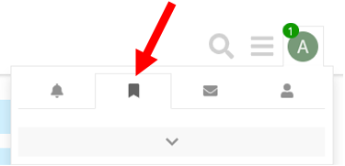

* + **Markdown**: Posts in Discourse are formatted using Markdown. When you create a post, you will see the raw markdown on the left and a preview on the right. Check out the [Markdown Cheatsheet](https://github.com/adam-p/markdown-here/wiki/Markdown-Cheatsheet) if you are not well versed with it and want a handy guide.
  + **Quoting**: To do a reply with quote, highlight the text you want to quote and a pop-up will appear saying "quote reply. Click it and that text will be copied to a new post. To reply to multiple posts in the same thread, repeat the process again until you get all your quotes.

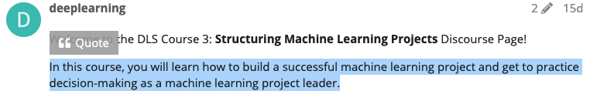

* + **Mentioning:** To notify someone about your reply, mention their name. Type @ to begin selecting a username. This search will also search the name fields in case you don’t know a particular username. Note - Please use mentioning only when needed otherwise you might be flagged for unnecessary tagging.
  + **Mark a reply as the solution:** As the topic creator you will have a button that allows you to accept an answer as the solution. Accepted answers will be highlighted on the initial topic and in the topic list.

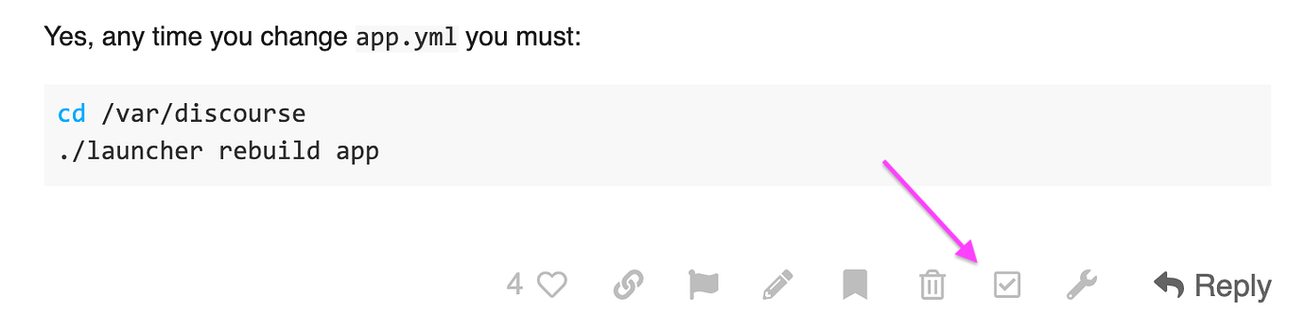

* + **Drafts:** To save a draft, when closing the editor, click “Save draft for later”.



To open a draft, return to the topic you were replying to or go to your profile icon on the top right corner and click “Drafts”.

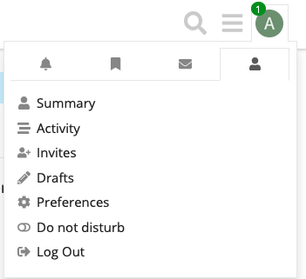

Note that if you are working on a long post, we recommend you save it externally as well in case Discourse wipes out your draft for unexpected reasons.

* + **Reply as a new topic:** Sometimes a topic may be closed, but you want to add to the conversation. Or you may want to start a new discussion based on an existing one. In this case, go to any post in the old topic and click on the timestamp. Click on  enable you to create a new topic that references the old one.

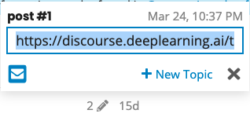

* **Inserting an image**: Besides using the upload button in the composer toolbar, you can simply drag & drop (it even works for multiple images at once )
* **Notifications:** When someone is talking directly to you — by replying to you, quoting your post, mentioning your @username , or even linking to your post, a blue number will immediately appear over your profile picture at the top right. Click your profile image to scroll through all your notifications.
* **Subscribing to categories and topics:**

To subscribe to a Topic (or thread) go to the topic, scroll to the bottom and click on the notifications dropdown.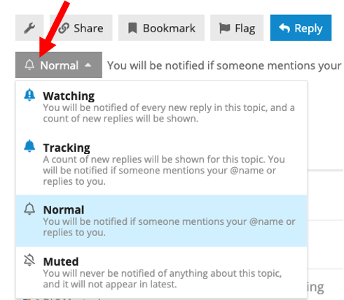

To subscribe to a Category, go to your preferences (via your Profile page) and click on Categories.

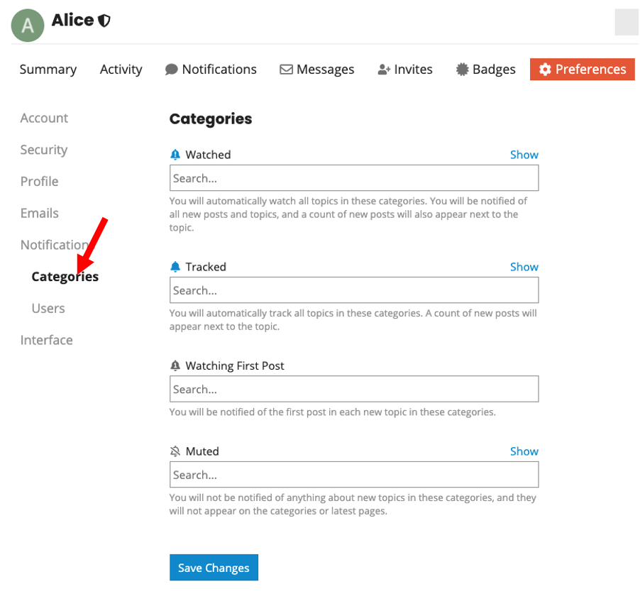

### User Trust Levels

You might notice that sometimes you don’t have access to upload an image in your post or edit your own posts after 24 hours. This is the user trust level setting, which is a fundamental cornerstone of Discourse. It represents a natural progression for participants in the community and is purely based on your interactions and engagement with your fellow community members.

There are 5 user trust levels in Discourse.

* + **Trust Level 0- New**: New users’ abilities are restricted for safety. For example, Users at trust level 0 cannot send personal messages to other users or edit your own posts after more than 24 hours.

## **Trust Level 1 – Basic**. By default, anyone joins Discourse via our invitation links start out at trust level 1. Users at trust level 1 can use all core Discourse functions including send PMs, upload images and attachments.

## **Trust Level 2 – Member**: Members have participated consistently and long enough to be trusted with full citizenship. Users at trust level 2 can edit their own posts for up to 30 days and ignore specific users if desired.

## **Trust Level 3 – Regular**: Regulars are the most active readers and reliable contributors. Users at trust level 3 can recategorize and rename topics, and have all their links followed.

## **Trust Level 4** – **Leader**: Leaders are typically DeepLearning.AI staff or mentors. Users at trust level 4 can edit all posts and pin/unpin topic.

To learn more about how to get promoted to the next trust level and what features are available for users at each level, visit [here](https://blog.discourse.org/2018/06/understanding-discourse-trust-levels/). Note that we have made some small changes to the criteria to make it easier for you to advance through the levels. Just do your best and don’t worry too much about it :)

### Getting setup

* + Complete your profile: when signing into Discourse for the first time, go to your profile and add a bit of introduction of yourself.
  + Introduce yourself in [DLS Introductions](https://discourse.deeplearning.ai/c/deep-learning-specialization/introductions/18)
  + Meet your mentors
  + Discourse is about connecting, contributing and supporting. When you are ready, start by replying to threads, clicking the like button of a topic, or creating a new topic to participate in the conversation.

We are here to support you along the way. If you have any questions, thoughts or ideas, we’d love to hear it! You can either open a topic in the [General Site Feedback](https://discourse.deeplearning.ai/c/site-feedback/2) or email us at [hello+discourse@deeplearning.ai.](mailto:hello+discourse@deeplearning.ai) Thank you!

**To learn more, here are some resources you can check out:**

* [User trust levels](https://blog.discourse.org/2018/06/understanding-discourse-trust-levels/)
* [Discourse New User Guide](https://meta.discourse.org/t/discourse-new-user-guide/96331)
* [Discourse Cheat sheet](https://www.sitepoint.com/community/t/discourse-cheat-sheet/733)